LOGIQUIDS PRACTICE TEST
Assessment 1 • Junior KG • 25 Questions
Name: ____________________ | Date: ______________ | Score: ______ / 25
How to answer: Look carefully at each question and draw a circle around the letter (A, B, C or D) of the correct answer. Parent can read the question aloud. Suggested time: 60 minutes.
Q1. What will come in place of "?" in the given series?
2-1-2, 2-2-2, 2-3-2, 2-4-2, ?
A 2-5-5 | B 5-2-5 | C 2-5-2 | D 2-6-2

Q2. What will come in place of "?" in the given series?
a, BB, c, DD, e, FF, ?
A G | B gg | C g | D HH

Q3. What will come in place of "?" in the given series?
10, 02, 30, 04, 50, 06, ?
A 70 | B 07 | C 08 | D 700

Q4. What will come in place of "?"
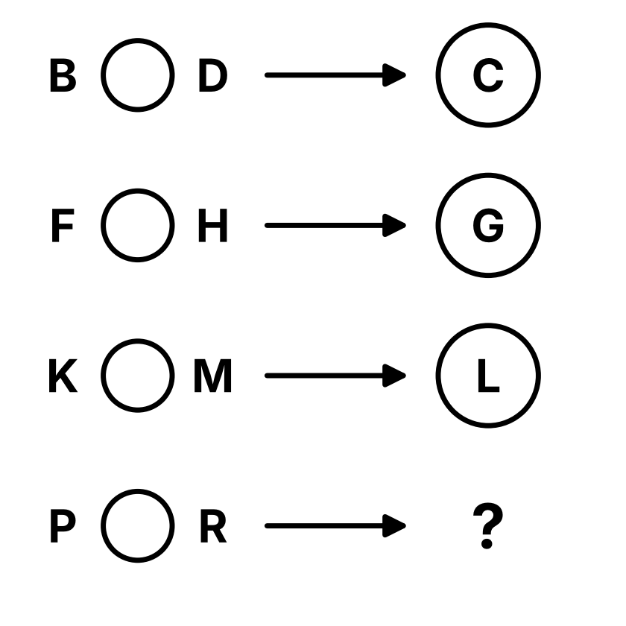
  A O | B Q
  C S | D R

Q5. What will come in place of "?"
BOOK → B_K
FISH → F_H
PLANT → P_T
LAMP → ?
A P_L | B L_A | C L_P | D A_P

Q6. What will come in place of "?"
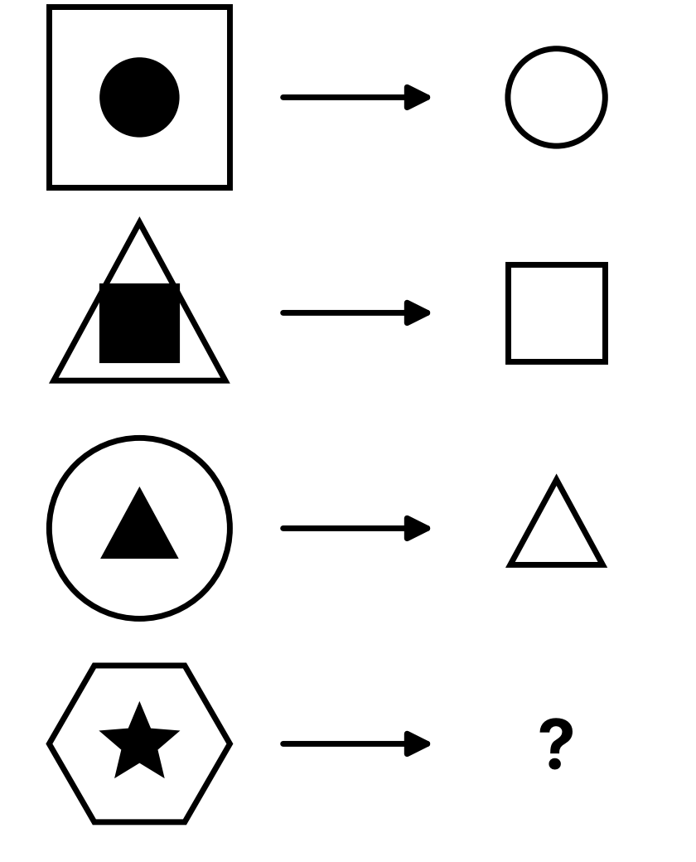
  A  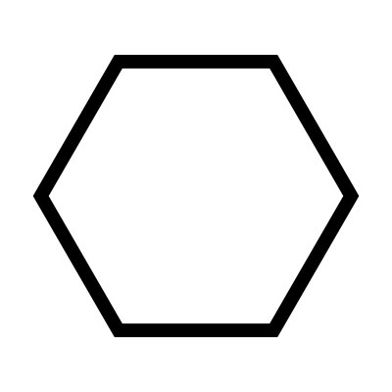 | B  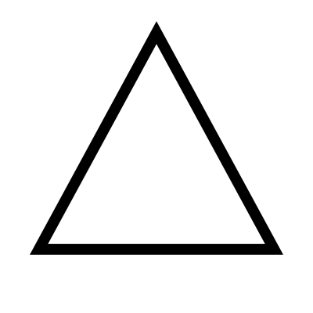
  C   | D  

Q7. What will come in place of the "?"
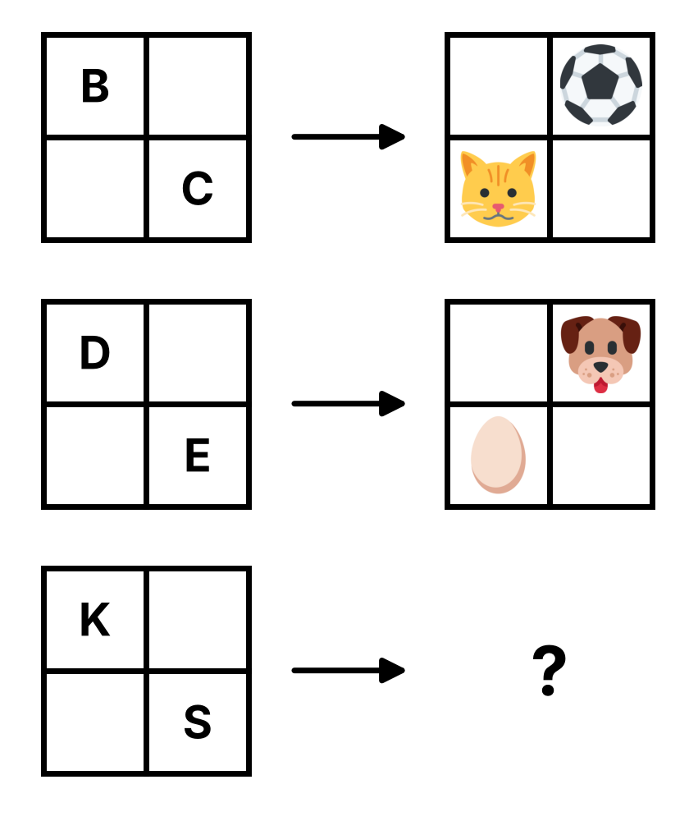
  A  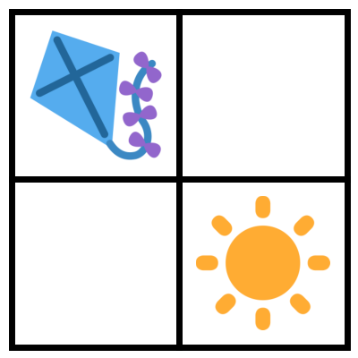 | B  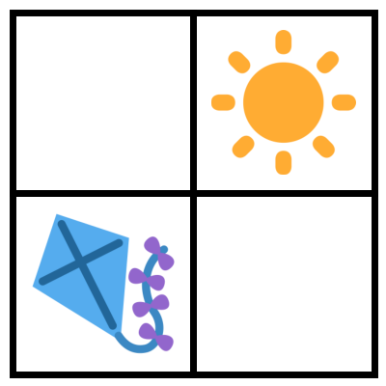
  C  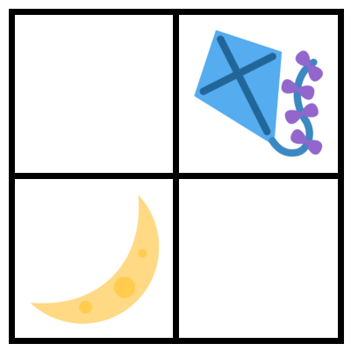 | D  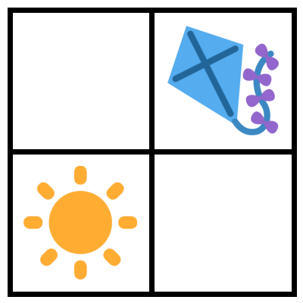

Q8. What will come in place of the "?"
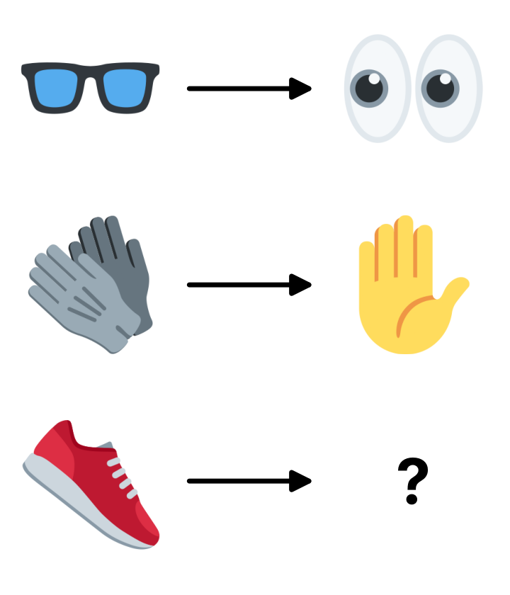
  A  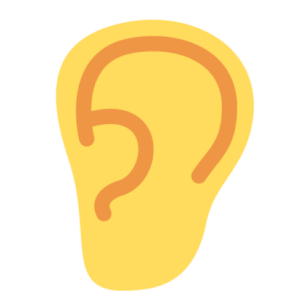 | B  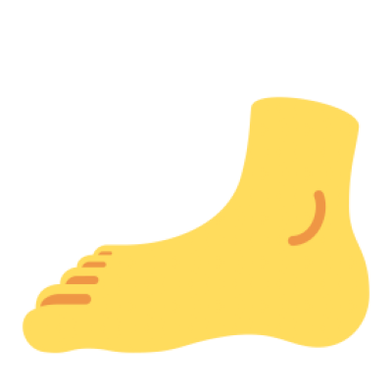
  C   | D  

Q9. Find the odd one out.
Note: It is not related to the number of letters, vowels or consonants of the words.
A 3 Four | B 8 Nine | C 5 Six | D 7 Six

Q10. Find the odd one out.
A   | B   | C  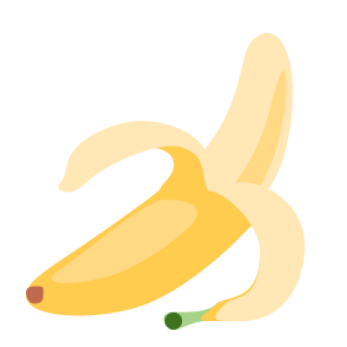 | D  

Q11. Find the odd one out.
Note: You may turn the shapes around in your mind.
A  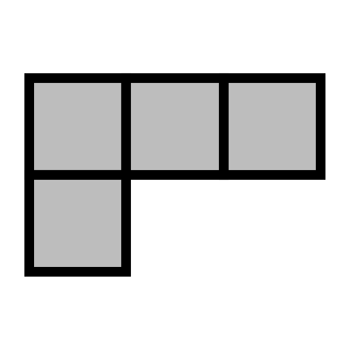 | B  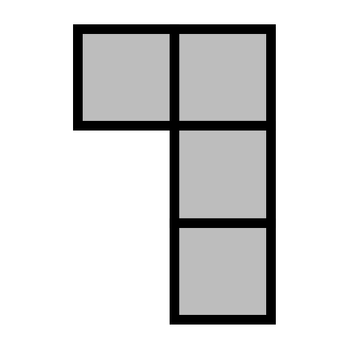 | C  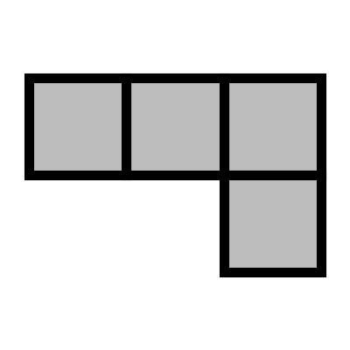 | D  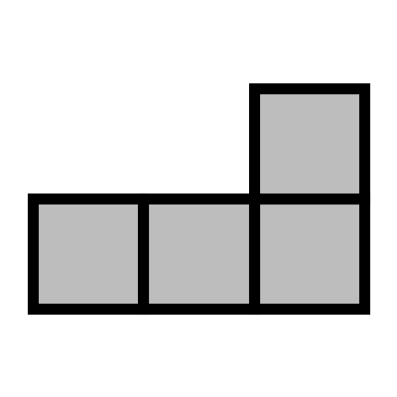

Q12. Which option is NOT a part of the question image?
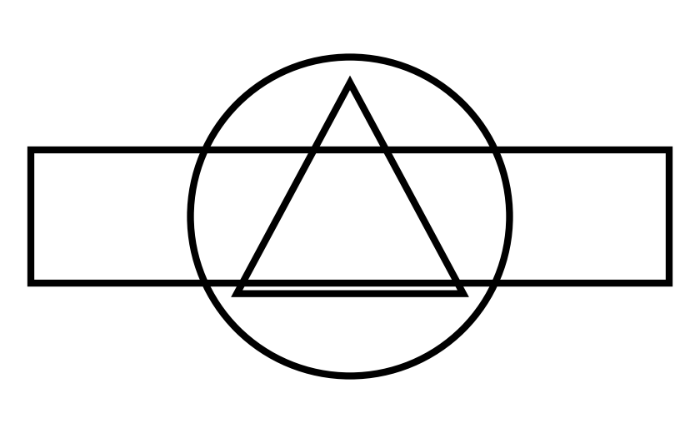
  A | B
  C | D  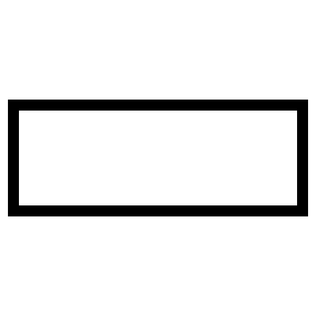

Q13. Which of the following objects is NOT present in the question image?
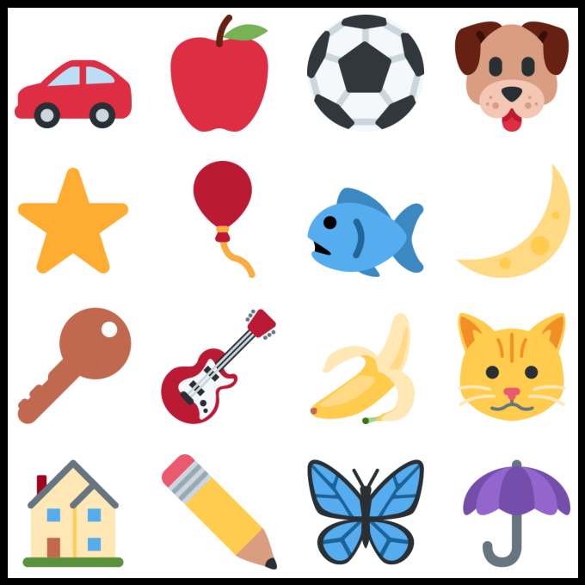
  A | B  
  C   | D  

Q14. Find the missing part of the image.
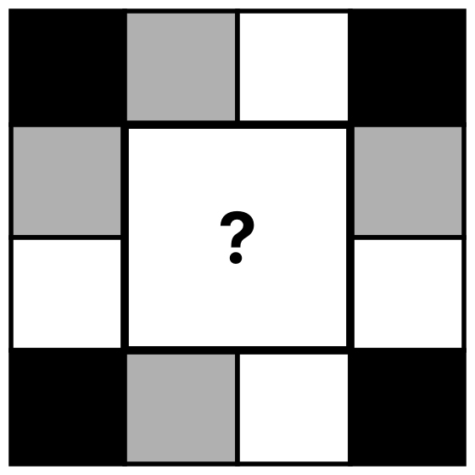
  A   | B  
  C  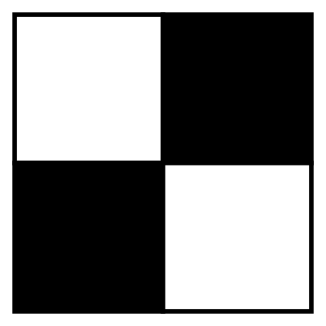 | D  

Q15. Which of the following options has the letter "Z" present in it?
Note: Images in the options cannot be rotated.
A  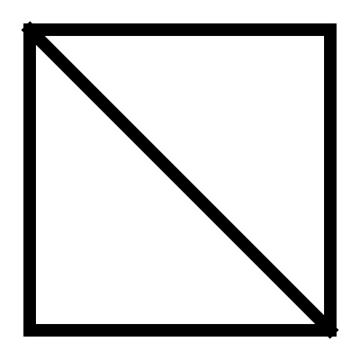 | B  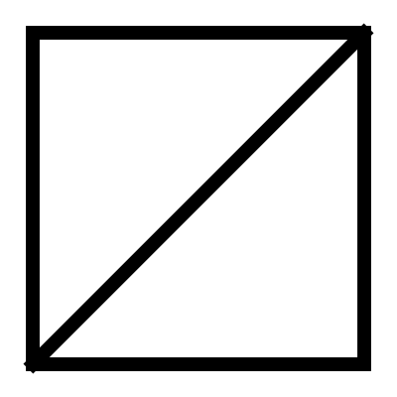 | C  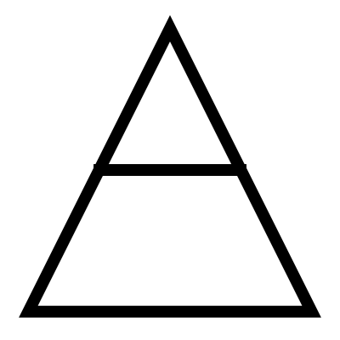 | D  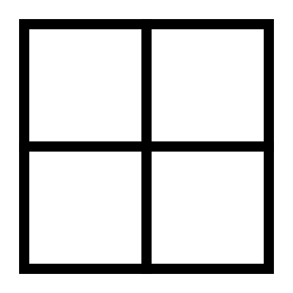

Q16. Find the missing half which is most similar to the image given below.
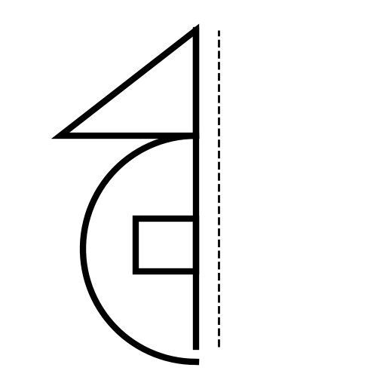
  A  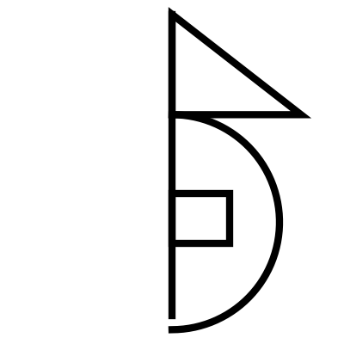 | B  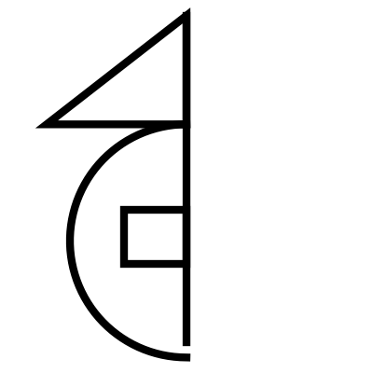
  C  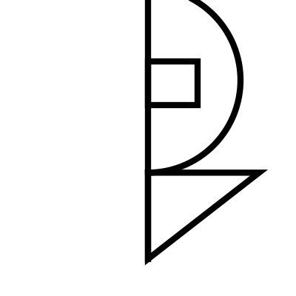 | D  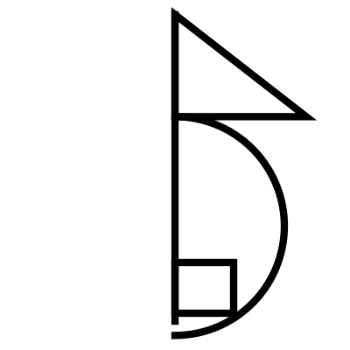

Q17. Count the number of circles in the image given below.
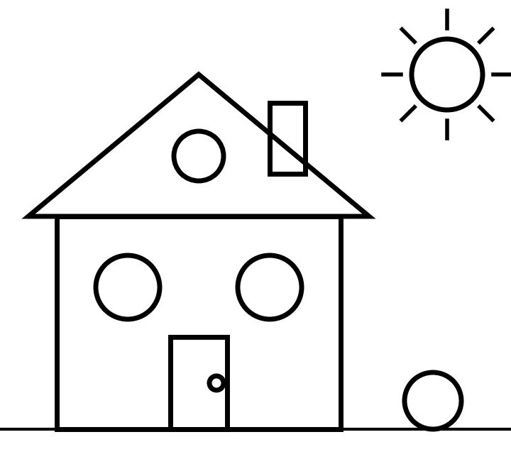
  A 4 | B 5
  C 6 | D 7

Q18. Count the number of rectangles in the given figure.
Note: Please count all the squares as rectangles for this question.
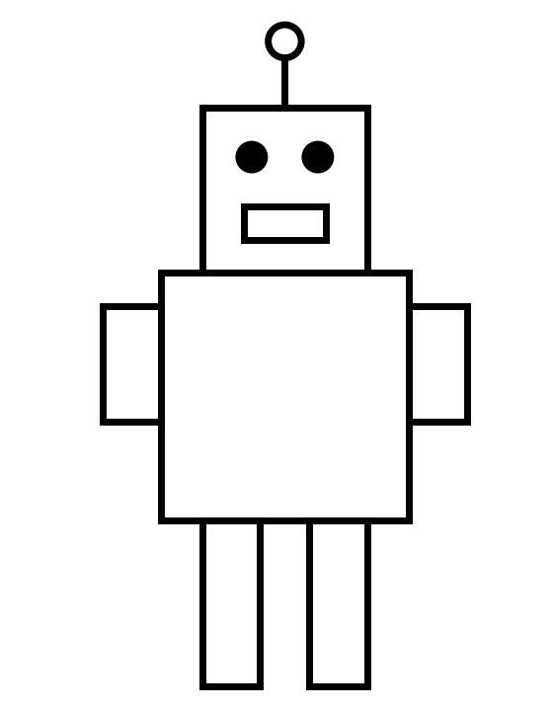
  A 5 | B 6
  C 7 | D 8

Q19. Count the number of small boxes with ONLY 3 BLACK stars in it.
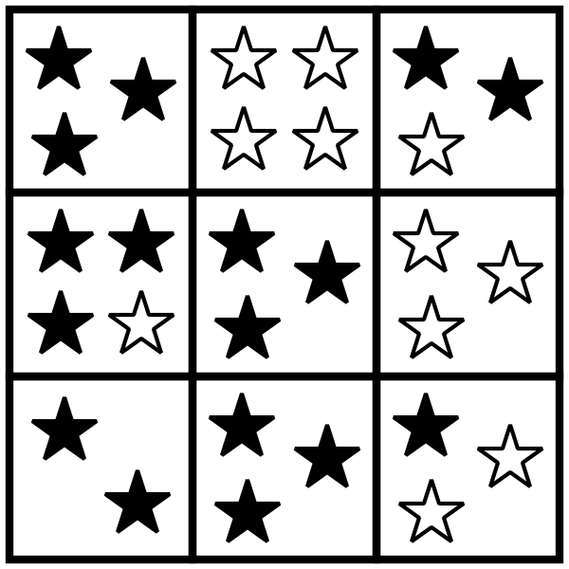
  A 3 | B 4
  C 5 | D 2

Q20. Which of the following options could be the shadow of the boat given in the question image?
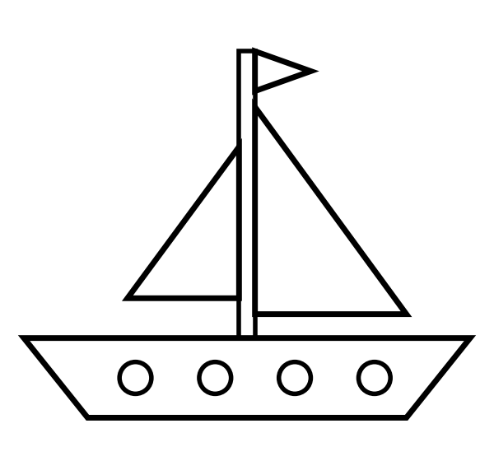
  A   | B  
  C   | D  

Q21. What will come in place of "?" ★ LQ Champ
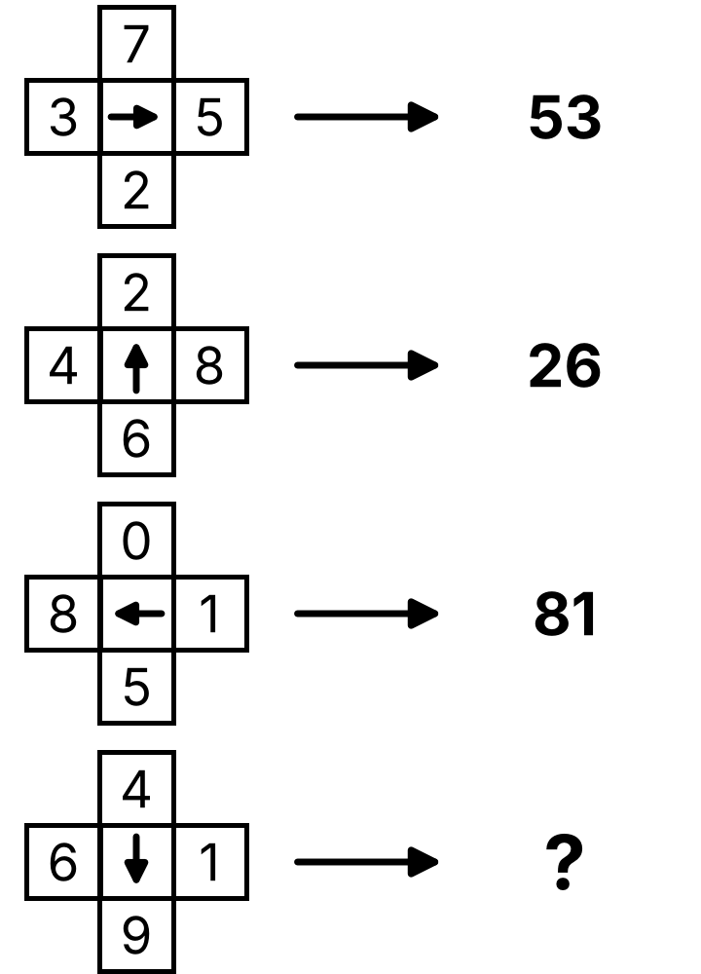
  A 49 | B 90
  C 94 | D 61

Q22. Count the number of triangles in the image given below. ★ LQ Champ
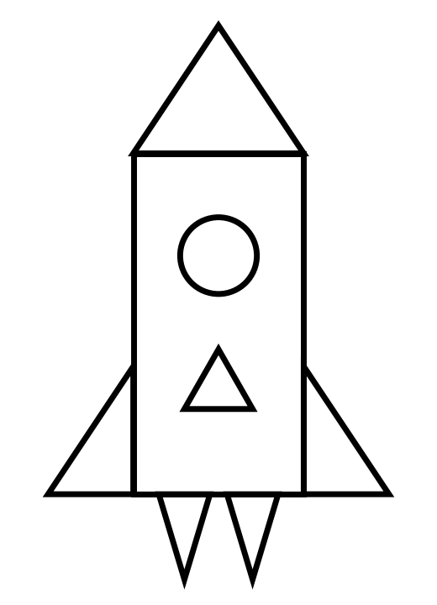
  A 6 | B 7
  C 8 | D 5

Q23. What will come in place of "?" in the given series? ★ LQ Champ
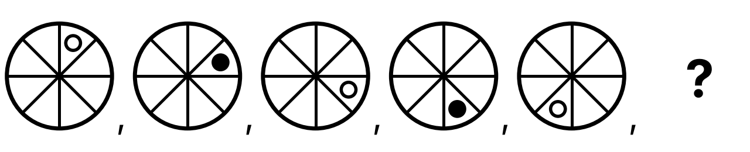
A  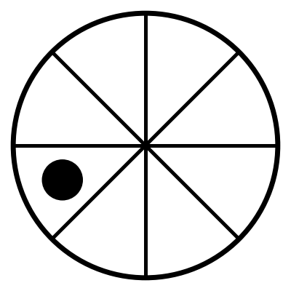 | B  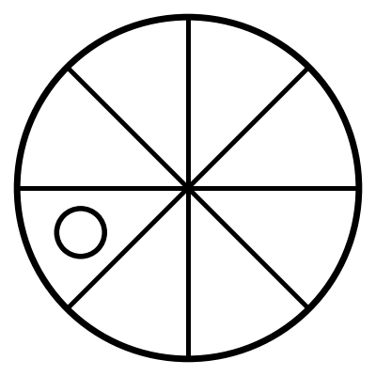 | C  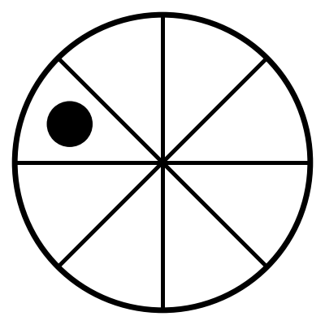 | D  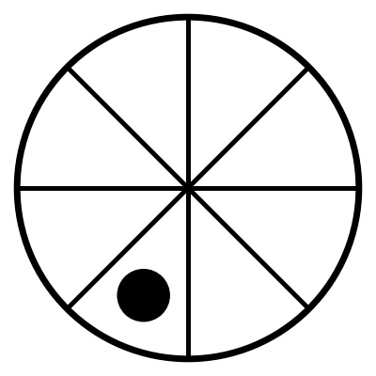

Q24. Which fruit is NOT HIDDEN behind the wall? ★ LQ Champ
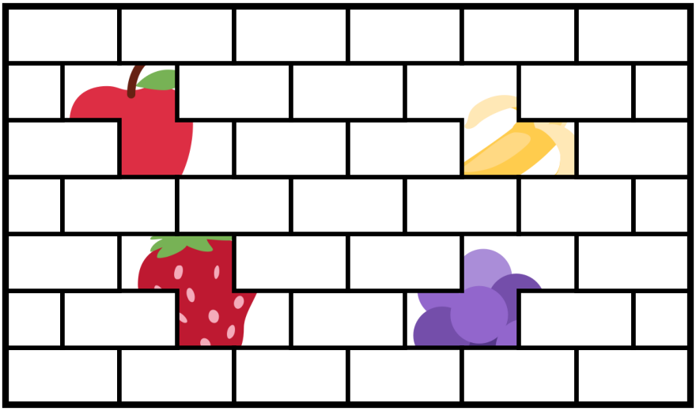
  A Apple | B Mango
  C Banana | D Strawberry

Q25. Which option is NOT present in the given image? ★ LQ Champ
Note: Rotation of an option image or part of it is not allowed.
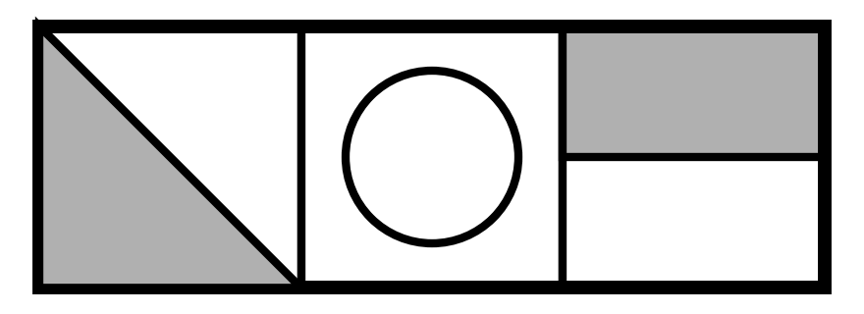
A  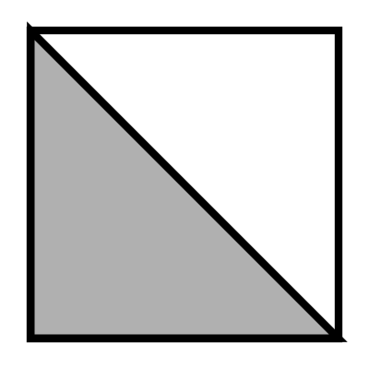 | B  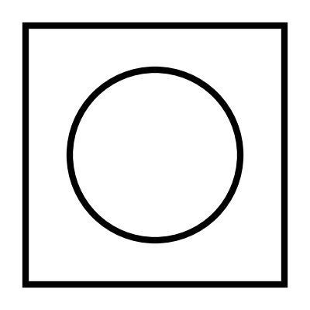 | C  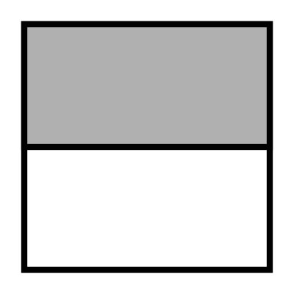 | D  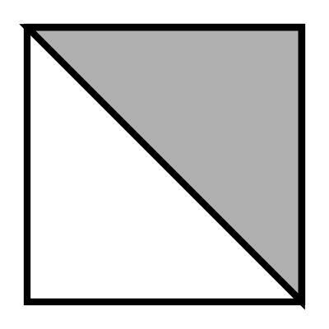

Answer Key — Assessment 1 (for parents)
Q | Answer | Why
1 | C | Middle number goes up by 1, ends stay 2
2 | C | Small letter, double capital letters, in order
3 | A | 1,3,5,7 with 00 after; 2,4,6 with 0 before
4 | B | The letter that comes between the two letters
5 | C | First letter _ last letter
6 | D | Answer is the black shape inside
7 | D | Top-left letter → its picture top-right; bottom-right letter → its picture bottom-left (Kite, Sun)
8 | B | Things we wear and where: shoe goes on foot
9 | D | Number is one less than the word in all others; 7 is more than Six
10 | B | Carrot is a vegetable, others are fruits
11 | C | C is a flipped (mirror) shape, others are turned
12 | A | There is no hexagon in the picture
13 | D | There is no elephant in the picture
14 | B | Diagonal pattern continues
15 | B | Top line, slanting line, bottom line make Z
16 | A | Mirror image of the half
17 | C | Round window, 2 windows, door knob, sun, ball
18 | C | Head, mouth, body, 2 arms, 2 legs
19 | A | Top-left, centre and bottom-middle boxes
20 | D | Flag points right, two sails, slanting boat
21 | C | Number at arrow head comes first, then tail: 9 then 4
22 | A | Nose, 2 fins, 2 flames, 1 on the body
23 | A | Dot moves one step clockwise and changes colour each time
24 | B | Apple, Banana, Strawberry, Grapes are hidden
25 | D | Grey triangle at top-right is not there

